**Exercise 5**

** Click on following link to get all the datasets required for this exercises

**1)**Open your **Top Website.pbix** Power BI report

Apply a filter to your matrix so that it misses out any categories containing the text **porn** (this is a family-oriented course, after all).

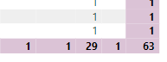

Create a slicer allowing someone to choose a continent:

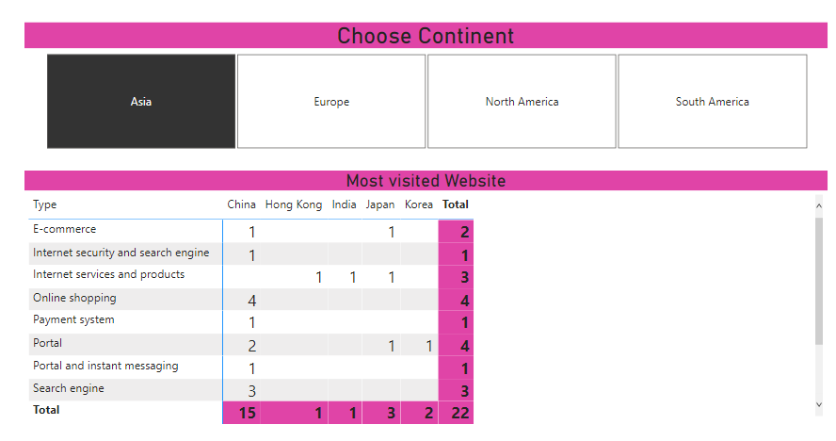

*What you should see if you choose****Asia.***

Curious to know which those 4 **online Shopping**sites are for **Asia**?

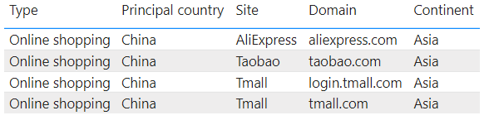

Save this report as **Filtered list**, then close it down.

**2)** Open **List of films** Power BI report - it contains a card, a table of films and a chart: 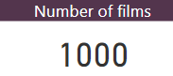

*Initially you're seeing all 1,000 films in the underlying data source.*

Apply a filter,so that you only see films which have won at least 2 Oscars

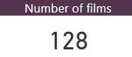

*You should see that there are only 128 films which have won 2 or more Oscars (and the table and chart should update to show just these films).*

 Add a slicer allowing you to see only the films for a genre of your choice:

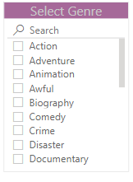

*Choose to search using your slicer, to allow you to choose the****Drama****genre.*

If you've done this correctly, you should see 24 as the number displayed in the card, and one of the world's dullest charts at the bottom of the page!

Save this report as **Sliced films**, then close it down.

**3)** Open **List of pizzas** Power BI report in the dataset folder:

*Initially the report just lists out every pizza served by Pizza Express (as of March 2019).*

You don't want to be a pig!  Add a numeric slicer allowing you to limit the calorie choice you face:

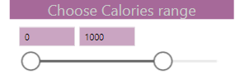

You don't want to be a pig, but you don't want someone to have stolen the middle of your pizza either.  Add a slicer allowing you to choose by pizza type:

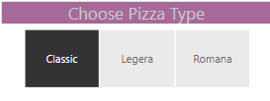

 It's surely got to be a **Sloppy Guiseppe**!

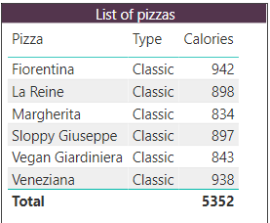

Save this report as **Slicer Pizza**, then close it down. 

**4)** Before you can do this exercise:

1. Go into SQL Server Management Studio;
2. Connect to **Create-a-Creature** database

Create a new Power BI report, and from the **Create-a-Creature** database load these tables:

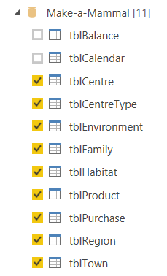

*Tick these tables to import them into your new report.*

 Create a report containing as many of the following slicers as you have time for!

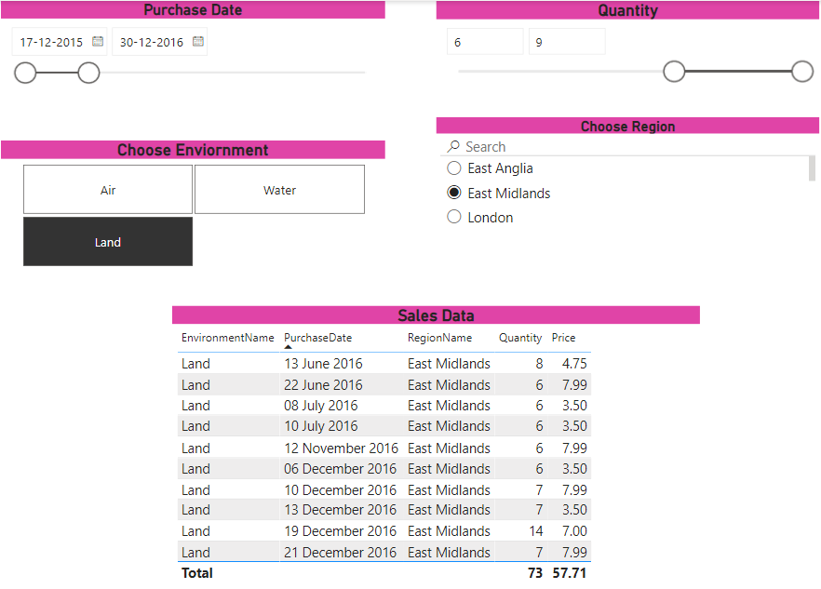

Save this report as **Mammal slicers**, then close it down.

**5**) Import data from the **Create-a-Creature** database by selecting the following tables:

Creating joins and connections

The goal is to create a report with one page of slicers which filter a second page containing no slicers but has a table. Create the first page like this:

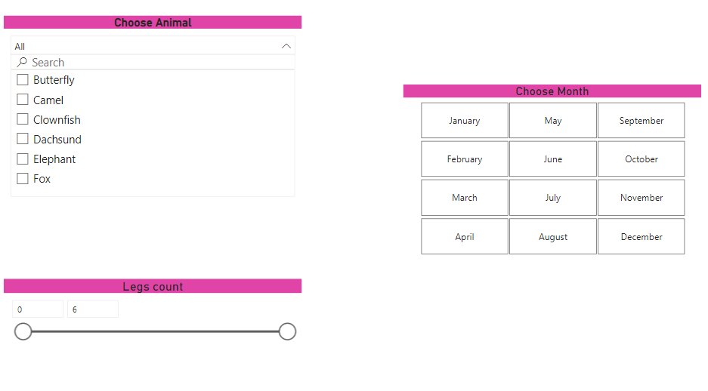

Then add a second page that has a visualisation containing the Quantity sales for the Animal column.

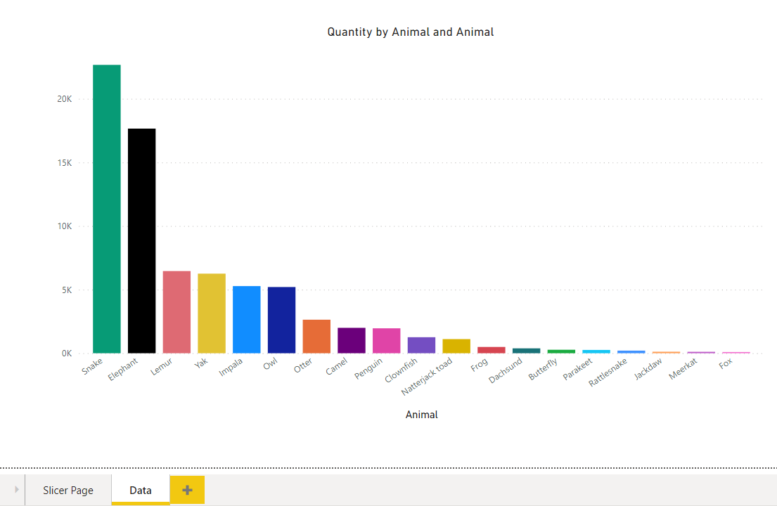

Repeat for each slicer then save as **Synchronised Slicing.pbix**.

**6)** Create a new Power BI Desktop file, and load into it sightings of **whales and porpoises** from the Whale and Dolphin Trust.

Create a slicer based on the data allowing you to choose the species sighted:

Now add a chart comparing sightings by month, but restrict this by choosing the slicer species shown:

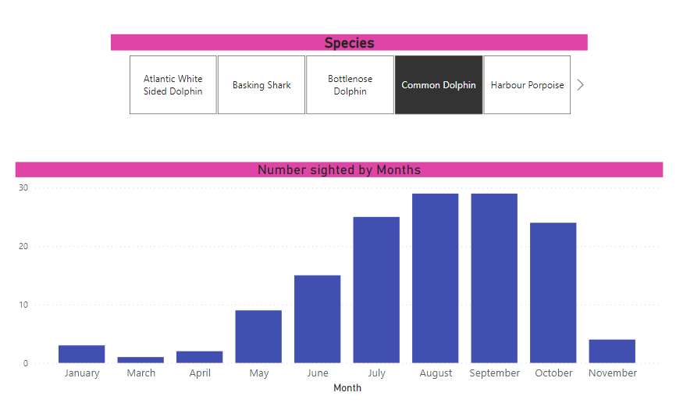

*omits any sightings by people called Jan.*

Save this workbook as **I love Dolphine**, then close down the Power BI instance containing it.

**7)** Before you can do this exercise, you'll need to load data from **Wiki buildings**

Create a new Power BI Desktop file

Using Query Editor, tidy up the data to look something like this:

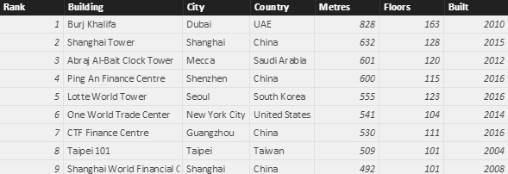

Now go back to Query Editor and add a custom column called Average Floor Height

Finally (!), create on a separate page of your report a slicer and chart so that you can see for any country the number of buildings per city:

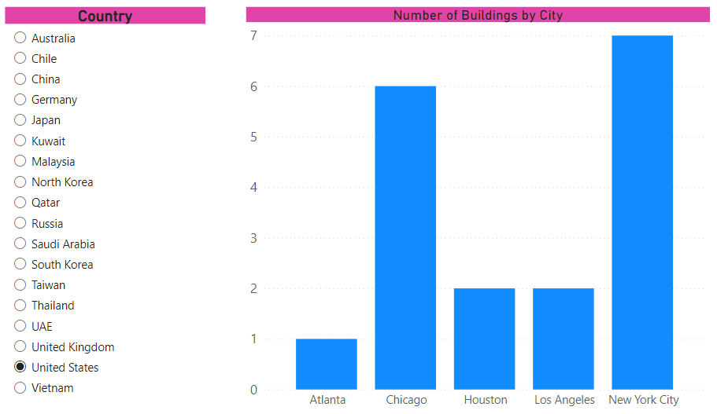

Save your file as **Size is not everything**, then close down the instance of Power BI Desktop.

**8)** Open **Events dear boy** Power BI report from dataset folder.

It contains 3 pages:

|  |  |
| --- | --- |
| Page | Contents |
| Choices | Empty |
| By decade | A chart comparing the number of world events by decade |
| List of events | A table listing all of the events in the underlying tables |

On the empty Choices page, add the following slicers:

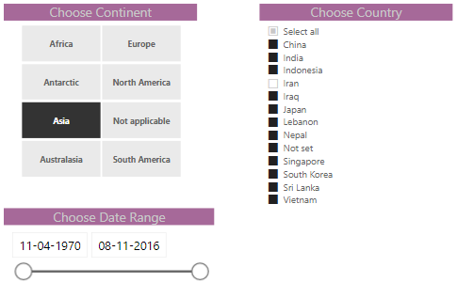

Now , configure your report so that the slicers only appear on the first page, but apply to the other pages:

Check that your filtering works across pages, then save your report as **Synchronicity**, and close it down.

**9)** Create a new Power BI Desktop file, and import into it the **crime** statistics in the Excel workbook in the above folder

Now create a text box, 3 slicers and a chart to compare as shown below:

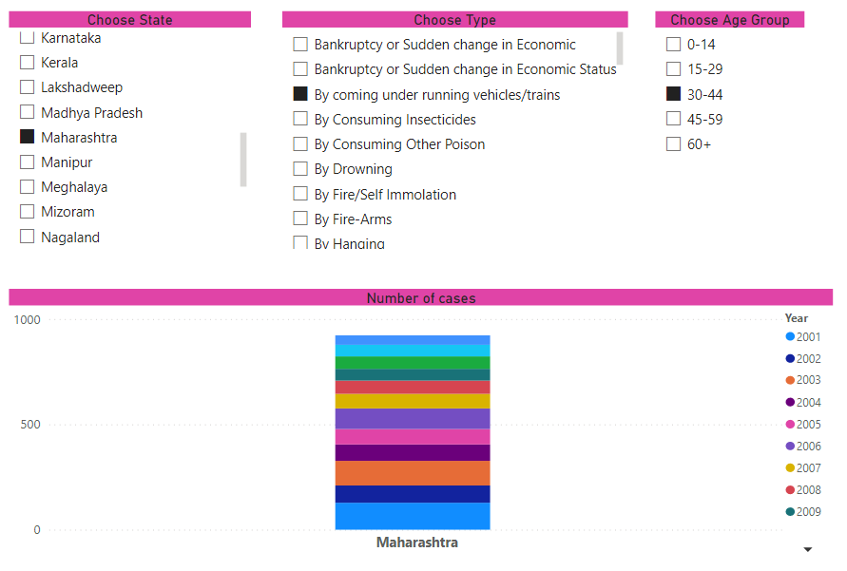

*You'll need to make sure child slicers don't affect parent ones, as well as applying colour saturation.*

Save this as **OMG**, and close down your current instance of Power BI Desktop.

**Drill Through:**

1) Open **All tests** Power BI report from dataset folder.  The aim of the exercise is as follows:

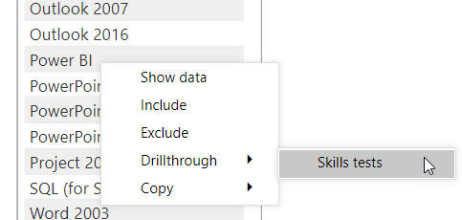

*Your aim should be to allow a user to right-click on an exam on the main page, and have this show an analysis of all of the tests taken for this exam on the second (hidden) page.*

To do this, apply a drill-through field to the (hidden) **Skill tests**page of the report.  You should then be able to drill through from the **List of exams**page.  Here's what you'd see if you right-click on Power BI and drill through, for example:

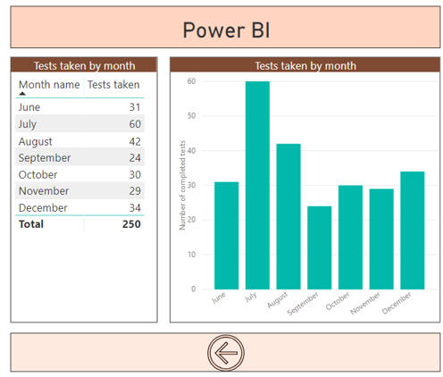

*The Power BI test was only published in June 2018. Try moving, resizing and formatting the back button created for you automatically so that it looks as shown above.*

Save this report as **Selected tests**, then close it down.

**Matrix**

1. Create a new Power BI Desktop file.

Connect to SQL Server Management studio for **Create-a-Creature** database.  From this load the following tables:

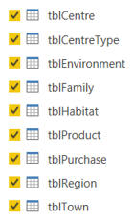

*Regular readers might experience a bit of deja vu at this point ...*

Create a chart showing sales by region and family:

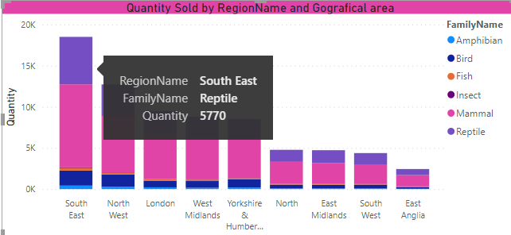

Now set drill-down so that when you click on a particular data point (such as the one shown in the previous diagram), you see sales data for that region's towns, and then for that particular town's shopping centres:

|  |  |
| --- | --- |
|  |  |
| *Drill-down to town level* | *Drill-down to centre level* |

Create a gauge, KPI and card to show the quantity of sales:

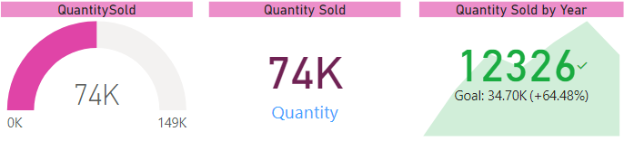

Remove drill-down, and change your settings so that clicking on a data point filters the gauge and KPI, but leaves the card unaffected:

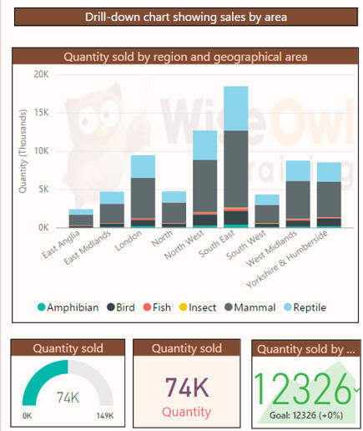

*Clicking on the bar for South-East Reptile sales updates the gauge and card, but has no effect on the centre visualisation (the card).*

Save this as **I’m loving Power BI**, then close down this instance of Power BI Desktop.